What will we be learning?  Breathing  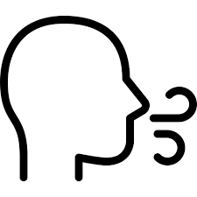 | Why this? Why now?  Previous Learning  The impact of exercise and lifestyle on the way the body functions (KS2); Movement  Future Learning  Respiration Topic.  GCSE – Organisation: Animal tissues, organs and organ systems; non- communicable diseases; human defence systems; Bioenergetics: Respiration.  Enquiry Processes  Analyse patterns, draw conclusions, present data, collect data, communicate ideas, critique claims, examine consequences. | Key Words:  Breathing  Trachea (windpipe)  Bronchi  Bronchioles  Alveoli  Ribs  Diaphragm  Lung volume  Ventilation  Gas Exchange  Pressure  Asthma  Smoking  (Respiration)
What will we learn?
- Breathing occurs through the action of muscles in the ribcage and diaphragm.
- How the parts of the gas exchange system are adapted to their function.
- How changes in volume and pressure inside the chest move gases in and out of the lungs
- In gas exchange, oxygen and carbon dioxide move between alveoli and the blood.
- Oxygen is transported to cells for aerobic respiration and carbon dioxide, a waste product of respiration, is removed from the body.
- The amount of oxygen required by body cells determines the rate of breathing.
- Explain observations about changes to breathing rate and volume, including how to carry out simple measurements of lung volume.
- How exercise, smoking and asthma affect the gas exchange system.
Misconceptions in this topic
- Respiration is not breathing - ventilation is breathing, respiration is a chemical rection inside the mitochondria of cells.
- The trachea leads to the lungs, the oesophagus leads to the stomach.
- Bronchus = singular; Bronchi = pleural.
What opportunities are there for wider study?
Careers
Doctor Nurse Physiotherapist Sports Scientist Personal Trainer
STE(A)M
https://highcliffe.sharepoint.com/sites/LearnSTEM
How will I be assessed?
End of topic assessment

